|  |  |  |  |
| --- | --- | --- | --- |
| 1 | | 8,304.0 | |
| NUMERO DE FRONTERAS | | ENERGIA AGREGADA | |
|  | | | |
| SI | | 04/09/2020 | |
| CONTRATO | | VENCIMIENTO CONTRATO | |
|  | | | |
| 23,281,517 | 99 | | 871,094 |
| INGRESO 2019 | DÍAS CERTIFICADOS 2019 | | ENERGIA RESPALDADA 2019 |
|  | | | |
| 20,276,737 | 90 | | 757,735 |
| INGRESO 2020 | DÍAS CERTIFICADOS 2020 | | ENERGIA RESPALDADA 2020 |
|  | | | |
| 19,925,093 | 105 | | 870,823 |
| INGRESO 2021 | DÍAS CERTIFICADOS 2021 | | ENERGIA RESPALDADA 2021 |

|  |
| --- |
| **ESTELAR MANZANILLO**  USUARIO |

|  |
| --- |
| **Mateo Porras**  Ejecutivo de cuenta |

|  |
| --- |
| **Jorge Alfonso Millán Guevara / Gerente Corporativo de Soporte Técnico / jorgea.millan@hotelesestelar.com**  Primera fecha: PUNTO FOCAL |

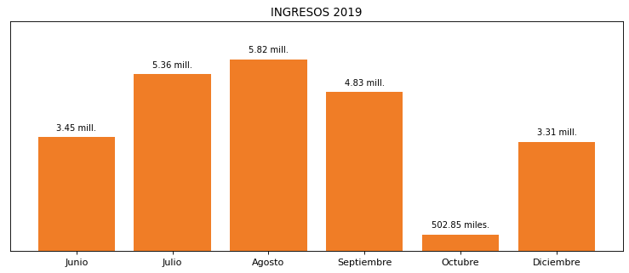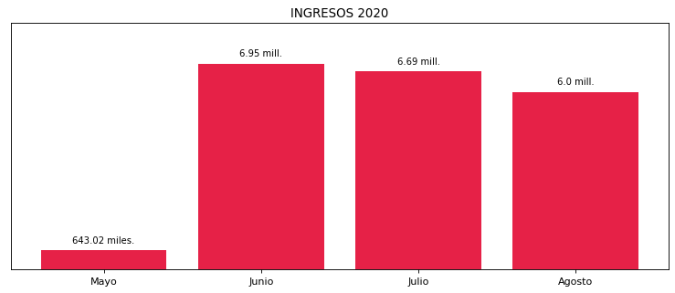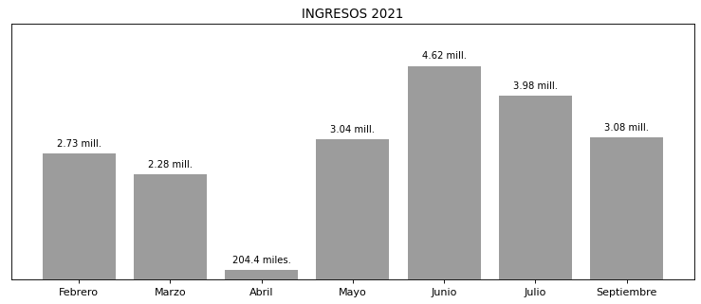

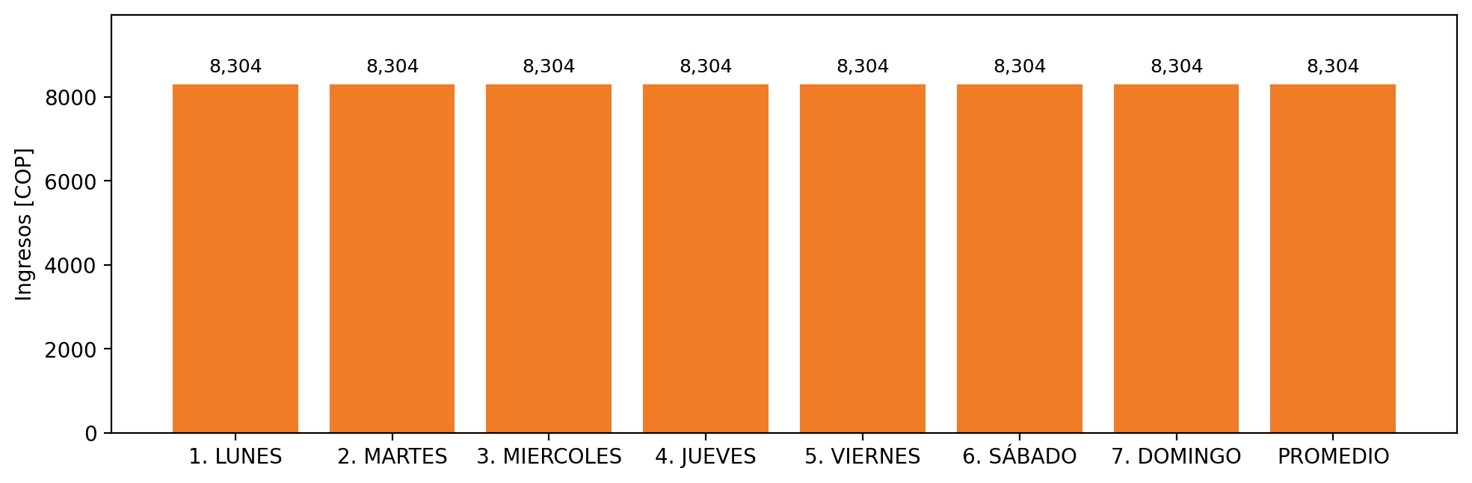

|  |  |  |  |  |  |  |  |  |  |
| --- | --- | --- | --- | --- | --- | --- | --- | --- | --- |
| **FRONTERA COMERCIAL** | **TIPO DDV** | **COD SIC** | **PREDIO** | **PROMEDIO** | **MARGEN** | **ÚLTIMA DESCONEXION** | **DÍAS CERTIFICADOS** | **ACTUALIZACION** | **PROXIMA PRUEBA DDV** |
| ESTELAR MANZANILLO | Frt36997 | Frt11369 | Prd01698 | 8,304 | NO APLICA | 2021-09-02 | 16.0 | 2023-04-15 | 2022-01-15 |